Anand Niketan school,

Mehsana



NAME:- Swetang Dhaval Pandit

CLASS:- 12th Science

SUBJECT:- Computer Science

PROJECT NAME:- Hospital Management System

SUBMITTED TO:- Jayna Sukhadia

INDEX

|  |  |
| --- | --- |
| INTRODUCTION | 3 |
| DESCRIPTION OF PROJECT | 5 |
| SYSTEM SPECIFICATION | 6 |
| SYSTEM DESIGN | 7 |
| Tables | 9 |
| SOURCE CODE | 12 |
| Output | 23 |
| MY SQL OUTPUT | 34 |
| Bibliograph | 36 |

# INTRODUCTION

## **SYNOPSIS**

The project keeps track of the staff and patient (in-patient, out-patient) details. It also takes care of the ward, medical, invoice and the doctor’s appointment details. The system generates the daily ward availability, the status of the operation theatres and ICU.

**HOSPITAL MANAGEMENT** is an integrated Hospital Information System, which addresses all the major functional areas of multi-specialty hospitals with all the details of staff, instruments and etc. The hospital management enables better patient care, patient safety, patient confidentiality, efficiency, reduced costs and better management information system. It provides easy access to critical information thus enabling the management to take better decisions on time.

This project deals with processing of each and every department in the hospital. This project sincerely aims to reduce the manual processing of each department. These reduces the work done on the papers and reduces the load of human to handle large number of files.

The Scope of the project takes care of the details of each and every department, instrument, and etc. These details gives the doctor, staffs, specialists, instrument, medicine and patient details including their salary, attendance , doctor’s appointments and the billing system. The details of Doctor and staff help the hospital to maintain the record of every person. Their attendance details help them to know about their attentive presence while salary is calculated. The billing system provides an efficient way for calculating bill details of the patients. It maintain the proper record of the things and person list for a long period of time.

# **DESCRIPTION OF PROJECT**

* To computerize all details regarding patient details & hospital details.
* To automate the process of ward entries.
* To maintain records effectively.
* To manage current status of staff and doctor availablity.
* The project has information regarding the inpatient details, outpatient details, medical instrument, Medicine, Billing details and Ambulance details.

# **SYSTEM SPECIFICATION**

## HARDWARE REQUIREMENTS:-

PROCESSOR : 11th Gen Intel(R) Core(TM) i5-1135G7

RAM : 8 G.B and more

HARD DISK DRIVE : 1 TB + 256GB

# SOFTWARE REQUIREMENTS:-

PROGRAMMING LANGUAGE : Python language

BACKEND : MSQL 5.1

FRONT END : Pycharm(python 3.10)

# **SYSTEM DESIGN**

THE SYSTEM DESIGN PROCESS: System design develops the architectural detail required to build a system or product. The system design process encompasses the following activities: • Partition the analysis model into subsystems.

• Identify concurrency that is dictated by the problem.

• Allocate subsystems to processors and tasks.

• Develop a design for the user interface.

• Choose a basic strategy for implementing data management.

• Identify global resources and the control mechanisms required to access them.

• Design an appropriate control mechanism for the system, including task management.

• Consider how boundary conditions should be handled.

• Review and consider trade-offs

. ***Input design:-*** Input design is a part of overall system design, requires the very careful analysis of the input data items. The goal of the input design is to make the data entry easier, logical and free from errors. The user controls input data. The commonly used input, output devices are mouse, keyboard and the visual display unit. The well designed, well organized screen formats are used to acquire the inputs. The data accepted is stored on database file. Our system is classified into subsystem such as

♣ Doctors Details

♣ Billing

♣ Patients details

♣ Room details

♣ Instrument

***Output Design***:- Output is the most important and direct source of information the user. Efficient & intelligent output design improves the system relationships with the users and helps in decision-making. The output is collected in order to help the user to make a wise decision

# **Tables**

create table doctors(name varchar(20),id int,age int,date_of_birth date,mobile_no int,specialization varchar(40),fees int,years_of_experience int);

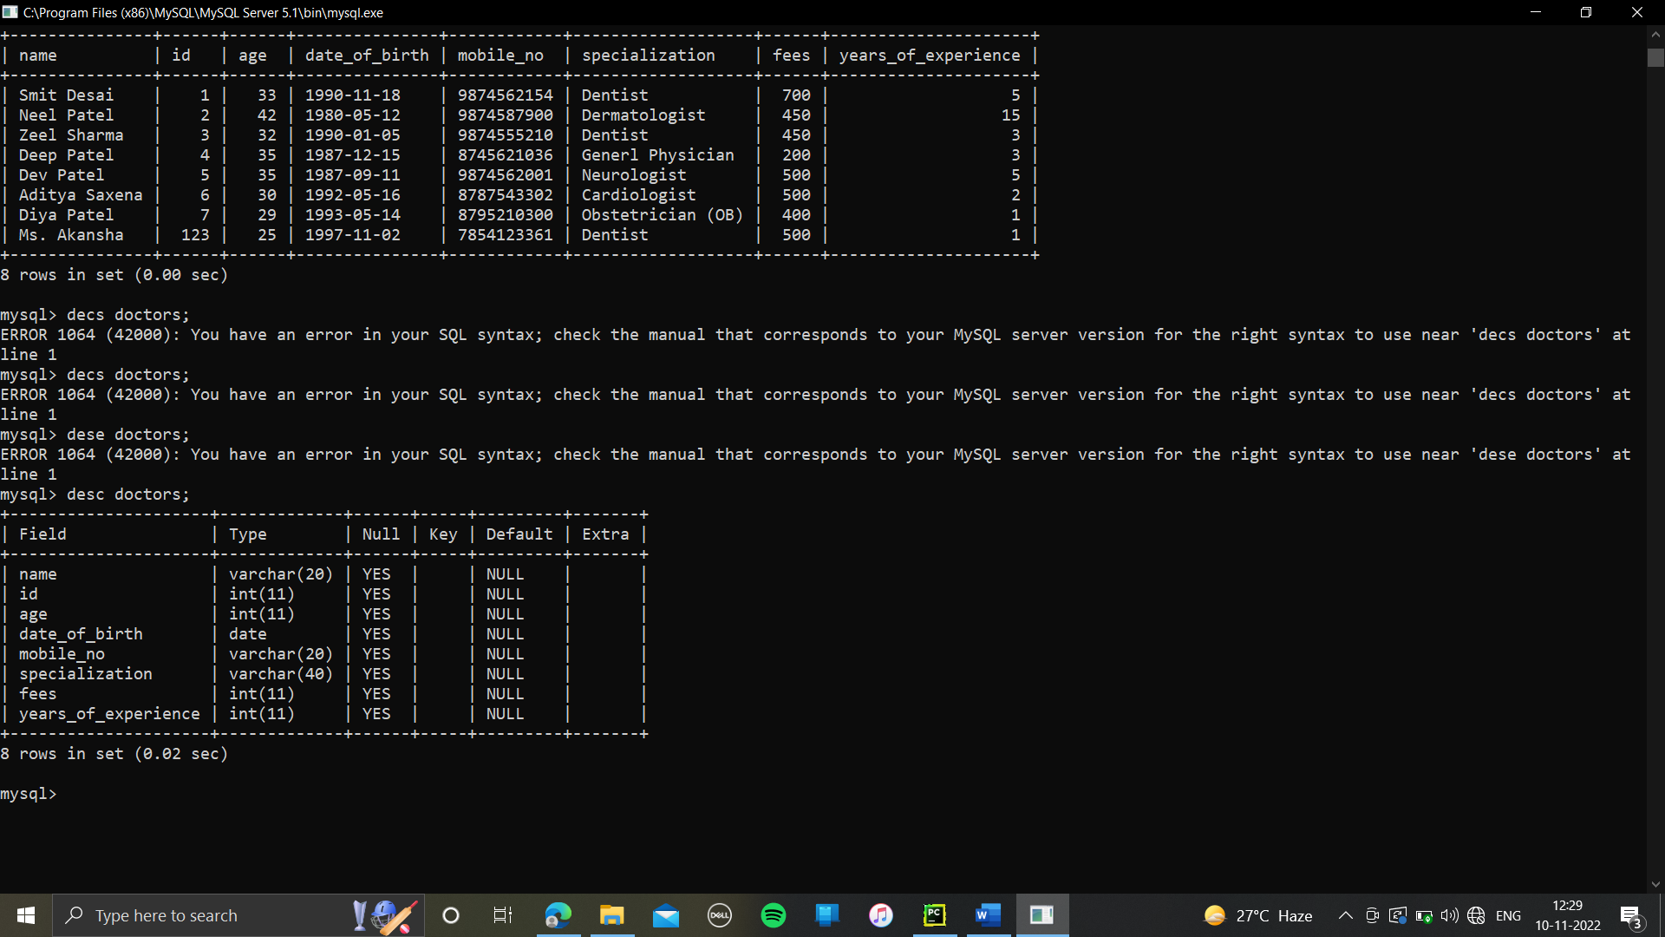

create table instrument(name_of_instrument varchar(50),id_of_instrument varchar(100),total_number_of_instrument int(50),date_of_purchase date,total_cost int(50),name_of_company varchar(50),name_of_department varchar(50),years_of_warranty int(50));

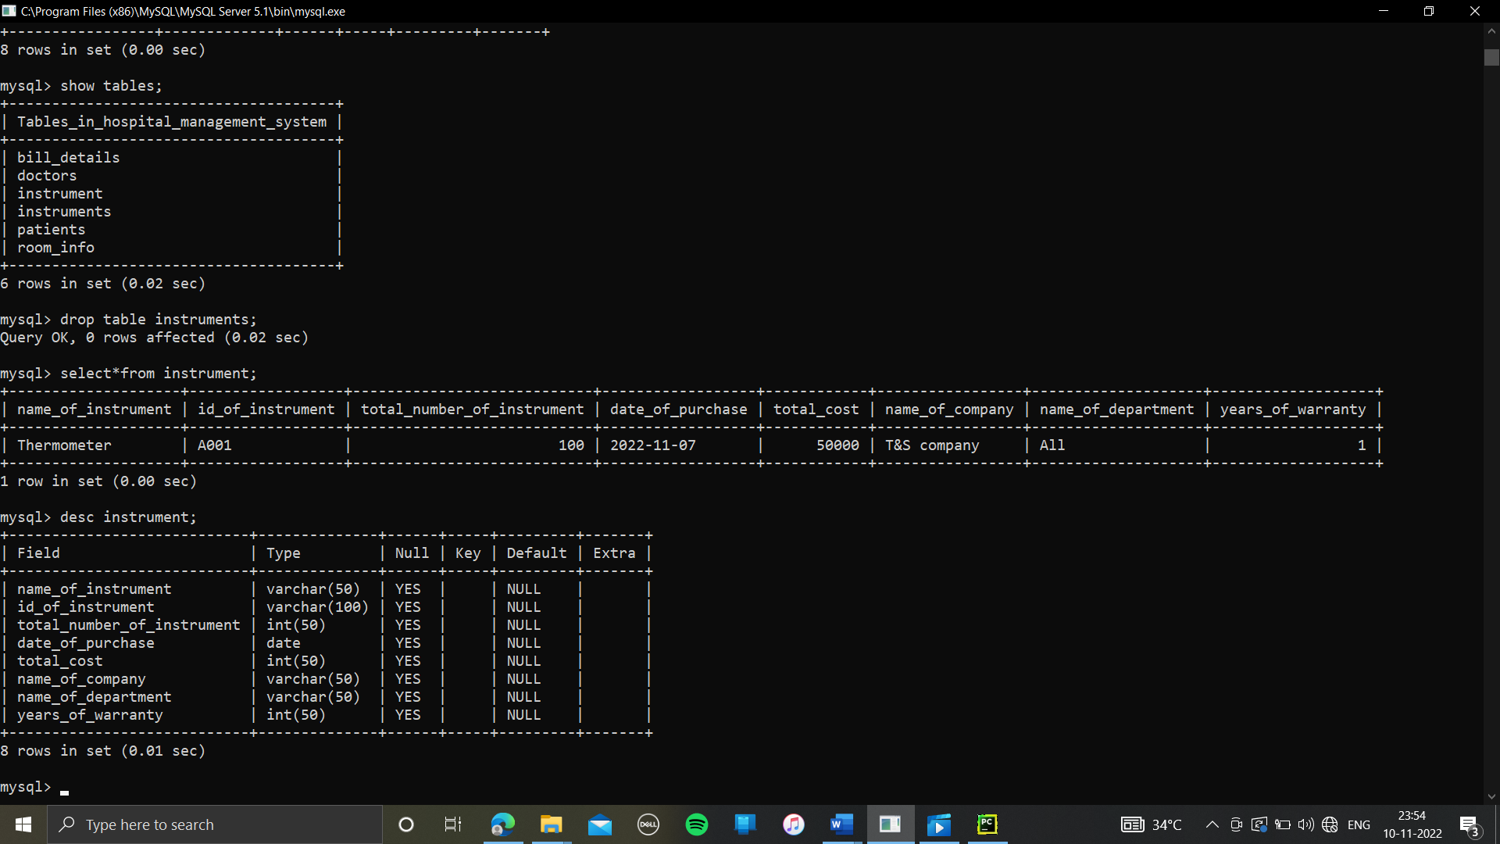

create table patients(patient_ID int,name varchar(20),age int,gender varchar(10),address varchar(20),contact_no int,date_of_birth date,consultant_name varchar(20), date_of_consultancy date,department varchar(20),consultancy_fees int);

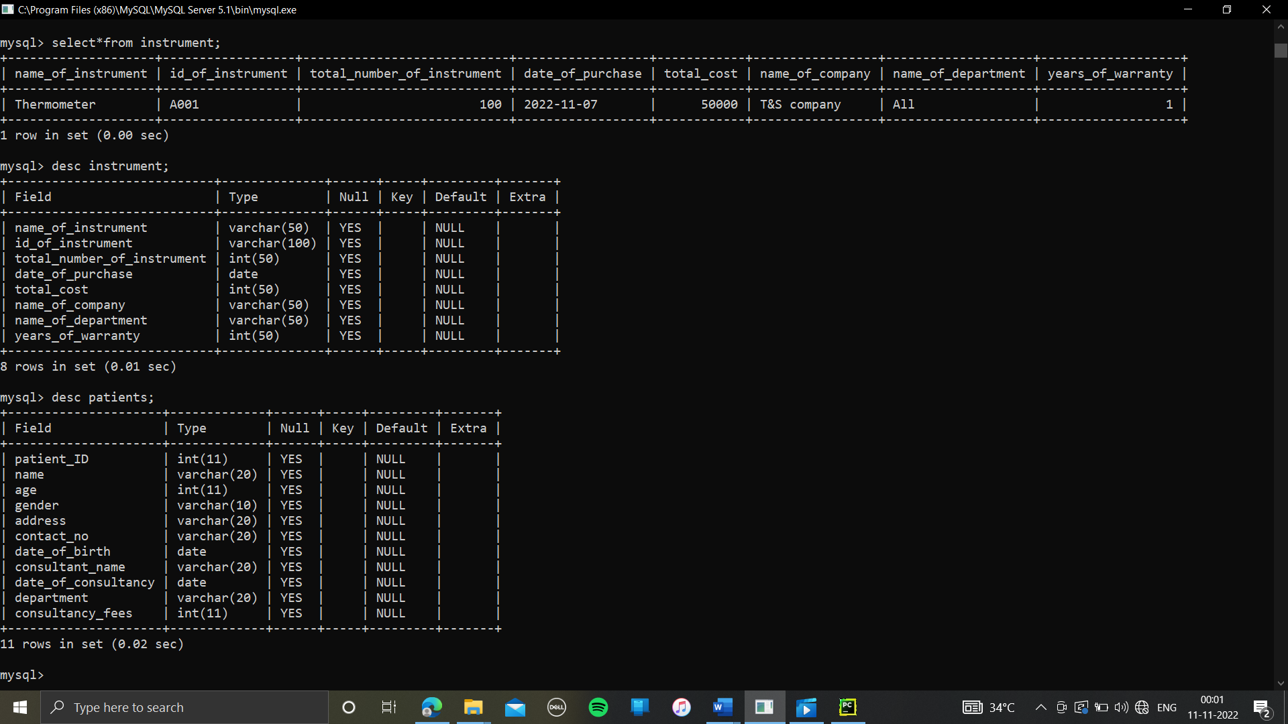

create table bill_details(bill_no int,bill_date date, name varchar(20), room_charges int,pathology_fees int,doctor_fees int,total_amount int,room_type varchar(20));

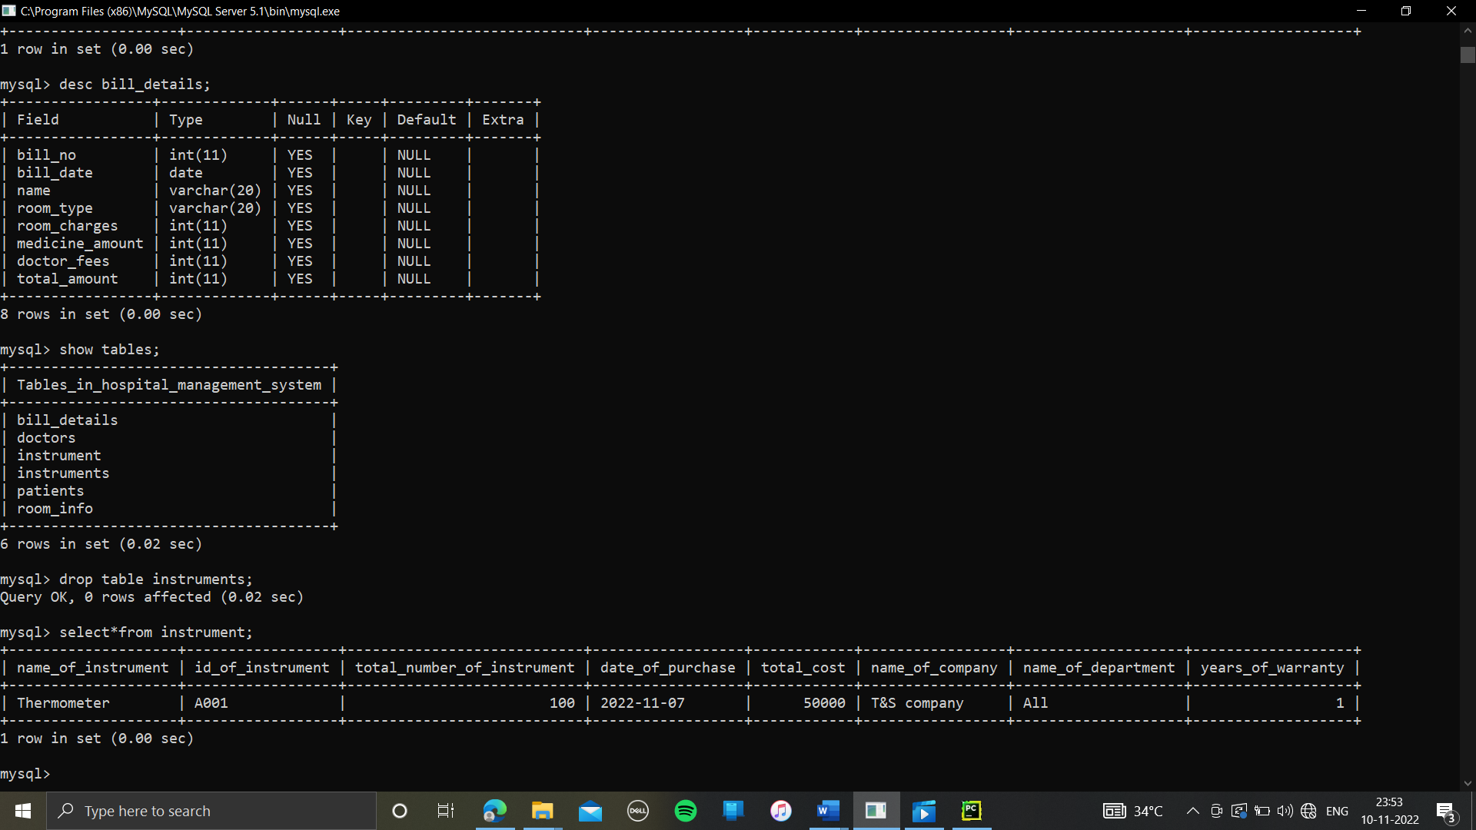

create table room_info(room_no int,room_type varchar(20),room_charges_per_day int,room_status varchar(20),patient_name varchar(20));

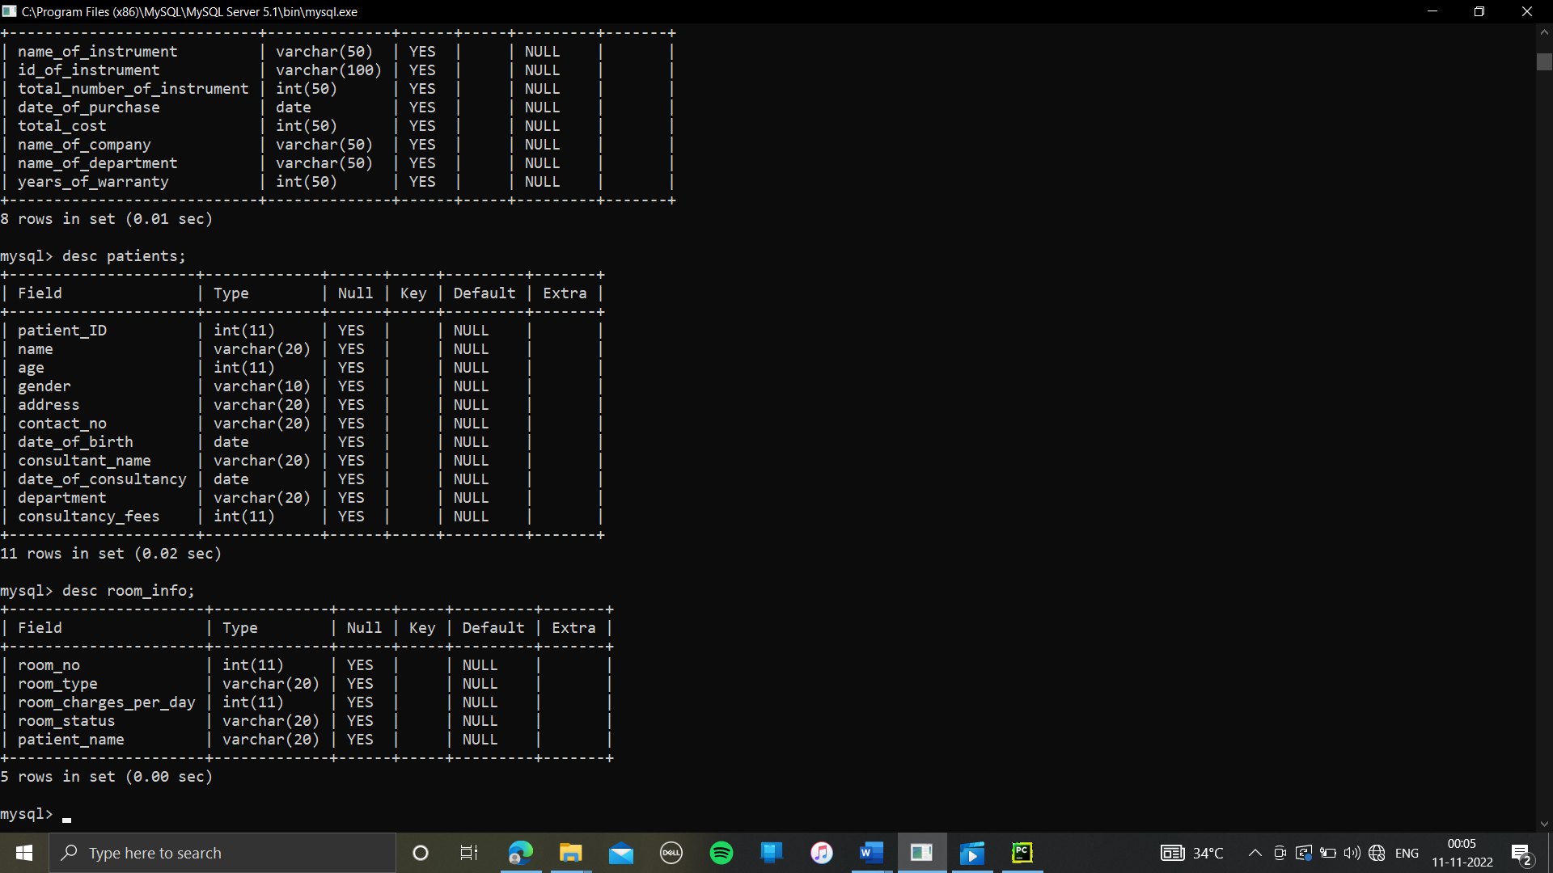

# **SOURCE CODE**

import mysql.connector as sq  
def connection():  
 try:  
 con = sq.connect(host="localhost", user="root", password="kspandit", database="hospital_management_system")  
 if con.is_connected() == False:  
 print("database not connected")  
 else:  
 return con  
 except sq.Error as er:  
 print(er)  
  
  
def insertion():  
 try:  
 con = connection()  
 cur = con.cursor()  
 name = input("Enter name of Doctor: ")  
 id = int(input("Enter id of Doctor: "))  
 age = int(input("Enter age of Doctor: "))  
 date_of_birth = input("Enter date of birth of Doctor: ")  
 mobile_no = input("Enter mobile no of Doctor: ")  
 specialization = input("Enter specialization of Doctor: ")  
 fees = int(input("Enter fees of Doctor: "))  
 years_of_experience = int(input("Enter years of experience: "))  
 cur.execute(  
 "insert into doctors(name,id,age,date_of_birth,mobile_no,specialization,fees,years_of_experience)values('%s',%d,%d,'%s','%s','%s',%d,%d)" % (  
 name, id, age, date_of_birth, mobile_no, specialization, fees, years_of_experience))  
 print()  
 print("Data inserted successfully")  
 con.commit()  
 except sq.Error as er:  
 print(er)  
  
  
def display():  
 try:  
 con = connection()  
 cur = con.cursor()  
 cur.execute("select * from doctors;")  
 for i in cur.fetchall():  
 print(i)  
 except sq.Error as er:  
 print(er)  
  
  
def updation():  
 try:  
 con = connection()  
 cur = con.cursor()  
 name = input("Enter name of Doctor: ")  
 id = int(input("Enter id of Doctor: "))  
 age = int(input("Enter age of Doctor: "))  
 date_of_birth = input("Enter date of birth of Doctor: ")  
 mobile_no = input("Enter mobile no of Doctor: ")  
 specialization = input("Enter specialization of Doctor: ")  
 fees = int(input("Enter fees of Doctor: "))  
 years_of_experience = int(input("Enter years of experience: "))  
 cur.execute(  
 "update doctors set name='%s',age=%d, date_of_birth='%s', mobile_no='%s', specialization='%s', fees=%d,years_of_experience=%d where id= %d" % (  
 name, age, date_of_birth, mobile_no, specialization, fees, years_of_experience, id))  
 print()  
 con.commit()  
 print("Data updated successfully")  
 except sq.Error as er:  
 print(er)  
  
  
def deletion():  
 try:  
 con = connection()  
 cur = con.cursor()  
 id = int(input("Enter id of doctors whose record you want to delete \nEnter id"))  
 cur.execute("delete from doctors where id= %d" % (id))  
 print()  
 con.commit()  
 print("Data Deleted successfully")  
 except sq.Error as er:  
 print(er)  
  
  
def insertion1():  
 try:  
 con = connection()  
 cur = con.cursor()  
 patient_ID = int(input("Enter id of Patient: "))  
 name = input("Enter name of Patient: ")  
 age = int(input("Enter age of Patient: "))  
 gender = input("Enter gender of Patient: ")  
 address = input("Enter address of Patient: ")  
 contact_no = input("Enter contact no of Patient: ")  
 date_of_birth = input("Enter date of birth of Patient: ")  
 consultant_name = input("Enter consultant name of Patient: ")  
 date_of_consultancy = input("Enter date of consultancy of Patient: ")  
 department = input("Enter department of Patient: ")  
 consultancy_fees = int(input("Enter consultancy fees of Patient: "))  
 cur.execute(  
 "insert into patients( patient_ID,name,age,gender,address,contact_no,date_of_birth,consultant_name,date_of_consultancy,department,consultancy_fees)values(%d,'%s',%d,'%s','%s','%s','%s','%s','%s','%s',%d)" % (  
 patient_ID, name, age, gender, address, contact_no, date_of_birth, consultant_name, date_of_consultancy,  
 department, consultancy_fees))  
 print()  
 print("Data inserted successfully")  
 con.commit()  
 except sq.Error as er:  
 print(er)  
  
  
def display1():  
 try:  
 con = connection()  
 cur = con.cursor()  
 cur.execute("select * from patients")  
 for i in cur.fetchall():  
 print(i)  
 except sq.Error as er:  
 print(er)  
  
  
def updation1():  
 try:  
 con = connection()  
 cur = con.cursor()  
 patient_ID = int(input("Enter id of Patient: "))  
 name = input("Enter name of Patient: ")  
 age = int(input("Enter age of Patient: "))  
 gender = input("Enter gender of Patient: ")  
 address = input("Enter address of Patient: ")  
 contact_no = input("Enter contact no of Patient: ")  
 date_of_birth = input("Enter date of birth of Patient: ")  
 consultant_name = input("Enter consultant name of Patient: ")  
 date_of_consultancy = input("Enter date of consultancy of Patient: ")  
 department = input("Enter department of Patient: ")  
 consultancy_fees = int(input("Enter consultancy fees of Patient: "))  
 cur.execute(  
 "update patients set name='%s',age=%d ,gender='%s',address='%s',contact_no='%s',date_of_birth='%s',consultant_name='%s',date_of_consultancy='%s',department='%s',consultancy_fees=%d where patient_ID= %d" % (  
 name, age, gender, address, contact_no, date_of_birth, consultant_name, date_of_consultancy, department,  
 consultancy_fees, patient_ID))  
 print()  
 con.commit()  
 print("Data updated successfully")  
 except sq.Error as er:  
 print(er)  
  
  
def deletion1():  
 try:  
 con = connection()  
 cur = con.cursor()  
 patient_ID = int(input("Enter id of patients whose record you want to delete \nEnter id"))  
 cur.execute("delete from patients where patient_ID= %d" % (patient_ID))  
 print()  
 con.commit()  
 print("Data Deleted successfully")  
 except sq.Error as er:  
 print(er)  
  
  
def insertion2():  
 try:  
 con = connection()  
 cur = con.cursor()  
 room_no = int(input("Enter Room no: "))  
 room_type = input("Enter Room type: ")  
 room_charges_per_day = int(input("Enter room charges per day: "))  
 room_status = input("Enter room status: ")  
 patient_name = input("Enter patient name: ")  
 cur.execute(  
 "insert into room_info(room_no, room_type, room_charges_per_day, room_status, patient_name )values(%d,'%s',%d,'%s','%s')" % (  
 room_no, room_type, room_charges_per_day, room_status, patient_name))  
 print()  
 print("Data inserted successfully")  
 con.commit()  
 except sq.Error as er:  
 print(er)  
  
  
def display2():  
 try:  
 con = connection()  
 cur = con.cursor()  
 cur.execute("select * from room_info")  
 for i in cur.fetchall():  
 print(i)  
 except sq.Error as er:  
 print(er)  
  
  
def updation2():  
 try:  
 con = connection()  
 cur = con.cursor()  
 room_no = int(input("Enter Room no: "))  
 room_type = input("Enter Room type: ")  
 room_charges_per_day = int(input("Enter room charges per day: "))  
 room_status = input("Enter room status: ")  
 patient_name = input("Enter patient name of occupied room: ")  
 cur.execute(  
 "update Room_Info set room_type='%s',room_charges_per_day=%d,room_status='%s',patient_name='%s'where room_no= %d" % (  
 room_type, room_charges_per_day, room_status, patient_name, room_no))  
 print()  
 con.commit()  
 print("Data updated successfully")  
 except sq.Error as er:  
 print(er)  
  
  
def deletion2():  
 try:  
 con = connection()  
 cur = con.cursor()  
 room_no = int(input("Enter room no from Room_Info whose record you want to delete \nEnter room no"))  
 cur.execute("delete from Room_Info where room_no= %d" % (room_no))  
 print()  
 con.commit()  
 print("Data Deleted successfully")  
 except sq.Error as er:  
 print(er)  
  
  
def insertion3():  
 try:  
 con = connection()  
 cur = con.cursor()  
 bill_no = int(input("Enter bill no: "))  
 bill_date = input("Enter bill date: ")  
 name = input("Enter name: ")  
 room_type = input("Enter room type: ")  
 room_charges = int(input("Enter room charges: "))  
 medicine_amount = int(input("Enter Medicine cost: "))  
 doctor_fees = int(input("Enter doctor fees: "))  
 total_amount = int(input("Enter total amount of bill: "))  
 cur.execute(  
 "insert into bill_details( bill_no, bill_date, name ,room_type, room_charges, medicine_amount, doctor_fees, total_amount )values(%d,'%s','%s','%s',%d,%d,%d,%d)" % (  
 bill_no, bill_date, name, room_type, room_charges, medicine_amount, doctor_fees, total_amount))  
 print()  
 print("Data inserted successfully")  
 con.commit()  
 except sq.Error as er:  
 print(er)  
  
  
def display3():  
 try:  
 con = connection()  
 cur = con.cursor()  
 cur.execute("select * from bill_details")  
 for i in cur.fetchall():  
 print(i)  
 except sq.Error as er:  
 print(er)  
  
  
def updation3():  
 try:  
 con = connection()  
 cur = con.cursor()  
 bill_no = int(input("Enter bill no: "))  
 bill_date = input("Enter bill date: ")  
 name = input("Enter name: ")  
 room_type = input("Enter room type: ")  
 room_charges = int(input("Enter room charges: "))  
 medicine_amount = int(input("Enter pathology fees: "))  
 doctor_fees = int(input("Enter doctor fees: "))  
 total_amount = int(input("Enter total amount of bill: "))  
 cur.execute(  
 "update bill_details set bill_date='%s', name='%s', room_type='%s', room_charges=%d, medicine_amount=%d, doctor_fees=%d, total_amount=%d where bill_no= %d" % (  
 bill_date, name, room_type, room_charges, medicine_amount, doctor_fees, total_amount, bill_no))  
 print()  
 con.commit()  
 print("Data updated successfully")  
 except sq.Error as er:  
 print(er)  
  
  
def deletion3():  
 try:  
 con = connection()  
 cur = con.cursor()  
 bill_no = int(input("Enter bill no from bil_ details whose record you want to delete \nEnter bill no"))  
 cur.execute("delete from bill_details where bill_no= %d" % (bill_no))  
 print()  
 con.commit()  
 print("Data Deleted successfully")  
 except sq.Error as er:  
 print(er)  
  
def insertion4():  
 try:  
 con = connection()  
 cur = con.cursor()  
 name_of_instrument = input("Enter name of Instrument: ")  
 id_of_instrument = input("Enter id of Instrument: ")  
 total_number_of_instrument = int(input("Enter the total number of Instrument ordered: "))  
 date_of_purchase = input("Enter date of purchase: ")  
 total_cost = int(input("Enter the cost of total Instrument bought: "))  
 name_of_company = input("Enter the company name it is bought from: ")  
 name_of_department = input("Enter the department it will be used: ")  
 years_of_warranty = int(input("Enter years of Instrument warranty: "))  
 cur.execute(  
 "insert into instrument(name_of_instrument,id_of_instrument,total_number_of_instrument,date_of_purchase,total_cost,name_of_company,name_of_department,years_of_warranty)values('%s','%s',%d,'%s',%d,'%s','%s',%d)" % (  
 name_of_instrument,id_of_instrument, total_number_of_instrument, date_of_purchase, total_cost, name_of_company, name_of_department, years_of_warranty))  
 print()  
 print("Data inserted successfully")  
 con.commit()  
 except sq.Error as er:  
 print(er)  
  
def display4():  
 try:  
 con = connection()  
 cur = con.cursor()  
 cur.execute("select * from instrument;")  
 for i in cur.fetchall():  
 print(i)  
 except sq.Error as er:  
 print(er)  
  
  
def updation4():  
 try:  
 con = connection()  
 cur = con.cursor()  
 name_of_instrument = input("Enter name of Instrument: ")  
 id_of_instrument = input("Enter id of Instrument: ")  
 total_number_of_instrument = int(input("Enter the total number of Instrument ordered: "))  
 date_of_purchase = input("Enter date of purchase: ")  
 total_cost = int(input("Enter the cost of total Instrument bought: "))  
 name_of_company = input("Enter the company name it is bought from: ")  
 name_of_department = input("Enter the department it will be used: ")  
 years_of_warranty = int(input("Enter years of Instrument warranty: "))  
 cur.execute(  
 "update instrument set name_of_instrument='%s',total_number_of_instrument=%d, date_of_purchase='%s', total_cost=%d, name_of_company='%s', name_of_department='%s',years_of_warranty=%d where id_of_instrument= '%s'" % (  
 name_of_instrument, total_number_of_instrument, date_of_purchase, total_cost, name_of_company, name_of_department, years_of_warranty, id_of_instrument))  
 print()  
 con.commit()  
 print("Data updated successfully")  
 except sq.Error as er:  
 print(er)  
  
  
def deletion4():  
 try:  
 con = connection()  
 cur = con.cursor()  
 id_of_instrument = input("Enter id of instrument whose record you want to delete \nEnter id")  
 cur.execute("delete from instrument where id_of_instrument= '%s'" % (id_of_instrument))  
 print()  
 con.commit()  
 print("Data Deleted successfully")  
 except sq.Error as er:  
 print(er)  
  
  
def menu():  
 try:  
 print("============>WELCOME TO HOSPITAL MANAGEMENT SYSTEM<============")  
 print()  
 print("Select Your Choice From The Given Alternatives")  
 print()  
 print(  
 "1.Add Record Of Doctors\n2.Update Record Of Existing Doctors\n3.Delete Record Of Doctors\n4.Access All The Records Of Doctors\n5.Add Record Of patients\n6.Update Record Of Existing patients\n7.Delete Record Of patients\n8.Access All The Records Of patients\n9.Add Record Of room info\n10.Update Record Of Existing room info\n11.Delete Record Of room info\n12.Access All The Records Of room info\n13.Add Records Of bill details\n14.Update Record Of Existing bill details\n15.Delete Record Of bill detais\n16.Access All The Records Of bill details\n17.Add Record of instrument\n18.Update Record Of Existing instrument\n19.Delete Record Of instrument\n20.Access All The Records Of instrument")  
 a = input("Enter Your Choice: ")  
 if a == '1':  
 insertion()  
 print()  
 print("Do You Want To Insert More Records?\nType Yes To Insert More Records And No To Stop")  
 a = input("Enter Your Choice")  
 if a == 'Yes':  
 insertion()  
 else:  
 print("Okay")  
  
 elif a == '2':  
 display()  
 print()  
 updation()  
 print()  
 print("Do You Want To Update More Records?\nType Yes To Update More Records And No To Stop")  
 b = input("Enter Your Choice")  
 if b == 'Yes':  
 updation()  
 else:  
 print("Okay")  
  
 elif a == '3':  
 display()  
 print()  
 deletion()  
 print()  
 print("Do You Want To Delete More Records")  
 c = input("Enter Your Choice")  
 if c == 'Yes':  
 deletion()  
 else:  
 print("okay")  
  
 elif a == '4':  
 display()  
  
 elif a == '5':  
 insertion1()  
 print()  
 print("Do You Want To Insert More Records?\nType Yes To Insert More Records And No To Stop")  
 d = input("Enter Your Choice")  
 if d == 'Yes':  
 insertion1()  
 else:  
 print("Okay")  
  
 elif a == '6':  
 display1()  
 print()  
 updation1()  
 print()  
 print("Do You Want To Update More Records?\nType Yes To Update More Records And No To Stop")  
 e = input("Enter Your Choice")  
 if e == 'Yes':  
 updation1()  
 else:  
 print("Okay")  
  
 elif a == '7':  
 display1()  
 print()  
 deletion1()  
 print()  
 print("Do You Want To Delete More Records")  
 f = input("Enter Your Choice")  
 if f == 'Yes':  
 deletion1()  
 else:  
 print("okay")  
  
 elif a == '8':  
 display1()  
  
 elif a == '9':  
 insertion2()  
 print()  
 print("Do You Want To Insert More Records?\nType Yes To Insert More Records And No To Stop")  
 g = input("Enter Your Choice")  
 if g == 'Yes':  
 insertion2()  
 else:  
 print("Okay")  
  
 elif a == '10':  
 display2()  
 print()  
 updation2()  
 print()  
 print("Do You Want To Update More Records?\nType Yes To Update More Records And No To Stop")  
 h = input("Enter Your Choice")  
 if h == 'Yes':  
 updation2()  
 else:  
 print("Okay")  
  
 elif a == '11':  
 display2()  
 print()  
 deletion2()  
 print()  
 print("Do You Want To Delete More Records")  
 i = input("Enter Your Choice")  
 if i == 'Yes':  
 deletion2()  
 else:  
 print("okay")  
  
 elif a == '12':  
 display2()  
  
 if a == '13':  
 insertion3()  
 print()  
 print("Do You Want To Insert More Records?\nType Yes To Insert More Records And No To Stop")  
 j = input("Enter Your Choice")  
 if j == 'Yes':  
 insertion3()  
 else:  
 print("Okay")  
  
 elif a == '14':  
 display3()  
 print()  
 updation3()  
 print()  
 print("Do You Want To Update More Records?\nType Yes To Update More Records And No To Stop")  
 k = input("Enter Your Choice")  
 if k == 'Yes':  
 updation3()  
 else:  
 print("Okay")  
  
 elif a == '15':  
 display3()  
 print()  
 deletion3()  
 print()  
 print("Do You Want To Delete More Records")  
 l = input("Enter Your Choice")  
 if l == 'Yes':  
 deletion3()  
 else:  
 print("okay")  
  
  
 elif a == '16':  
 display3()  
  
 if a == '17':  
 insertion4()  
 print()  
 print("Do You Want To Insert More Records?\nType Yes To Insert More Records And No To Stop")  
 a = input("Enter Your Choice")  
 if a == 'Yes':  
 insertion4()  
 else:  
 print("Okay")  
  
 elif a == '18':  
 display4()  
 print()  
 updation4()  
 print()  
 print("Do You Want To Update More Records?\nType Yes To Update More Records And No To Stop")  
 b = input("Enter Your Choice")  
 if b == 'Yes':  
 updation4()  
 else:  
 print("Okay")  
  
 elif a == '19':  
 display4()  
 print()  
 deletion4()  
 print()  
 print("Do You Want To Delete More Records")  
 c = input("Enter Your Choice")  
 if c == 'Yes':  
 deletion4()  
 else:  
 print("okay")  
  
 elif a == '20':  
 display4()  
  
 except sq.Error as er:  
 print(er)  
  
  
menu()

# Output

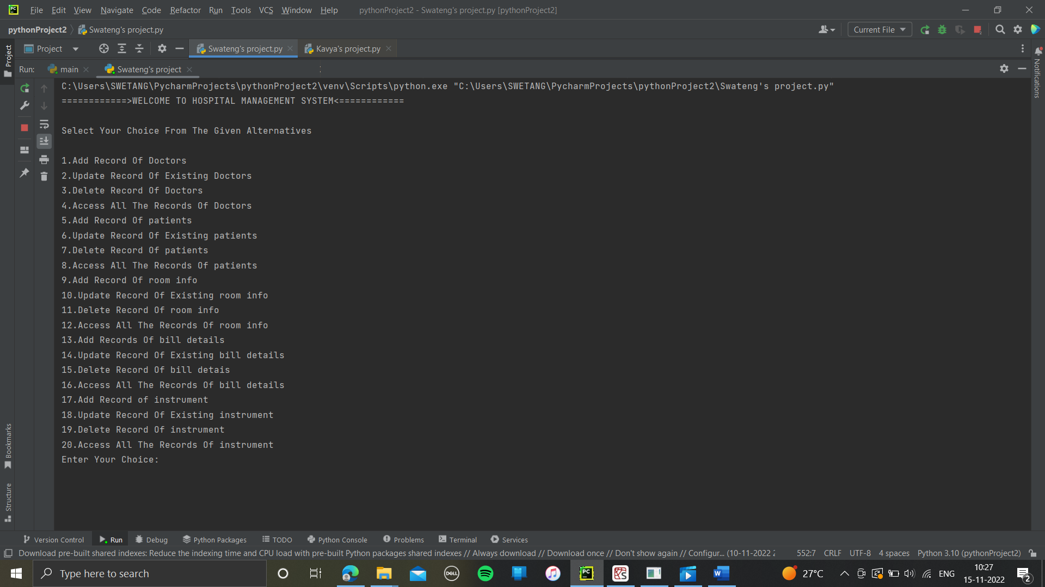

Add record of doctors:

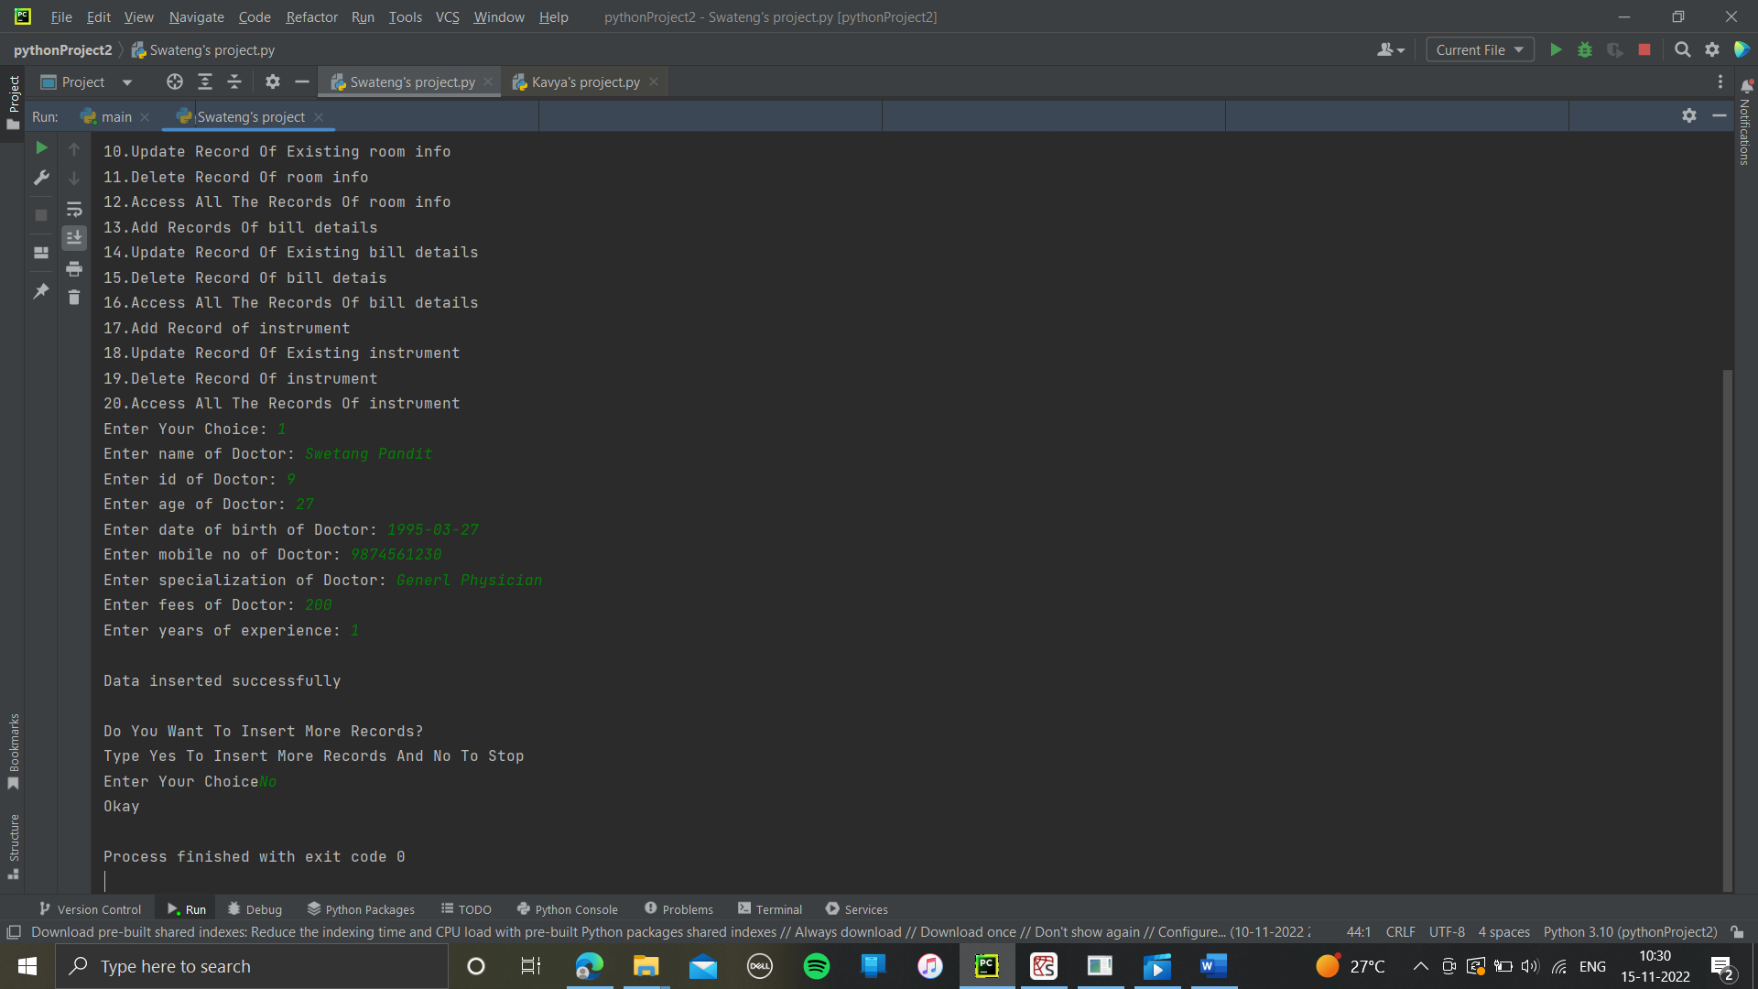

Update record of doctors:

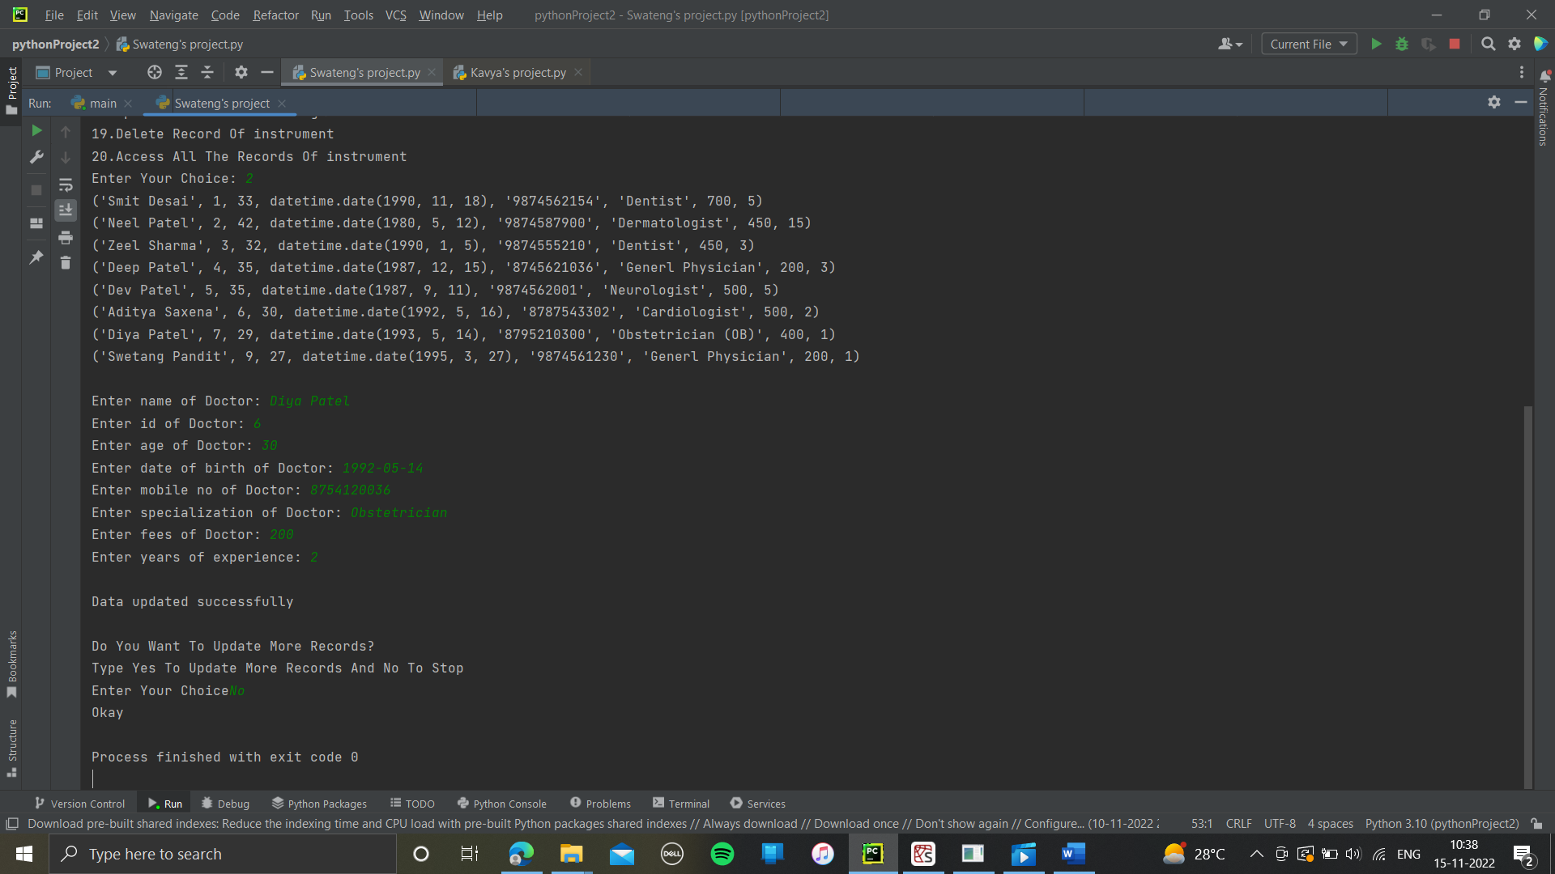

Delete the record of doctors:

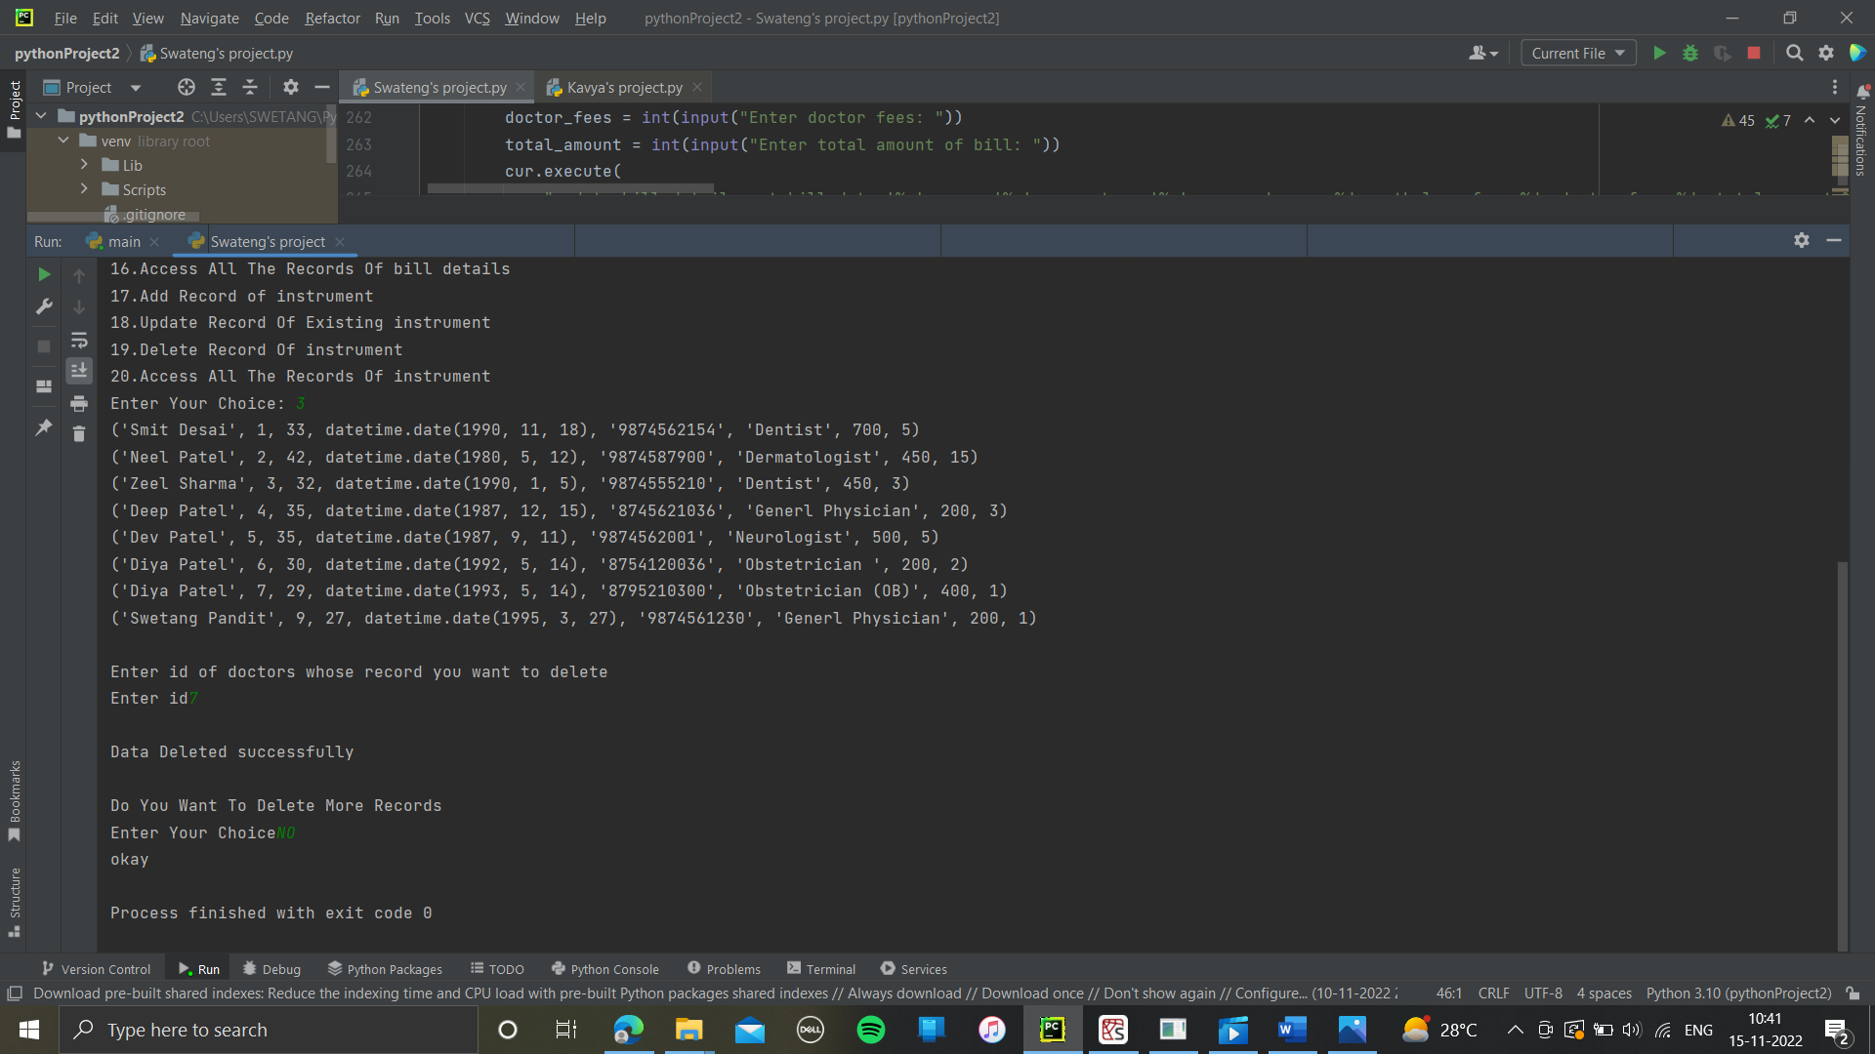

Display the record of doctors:

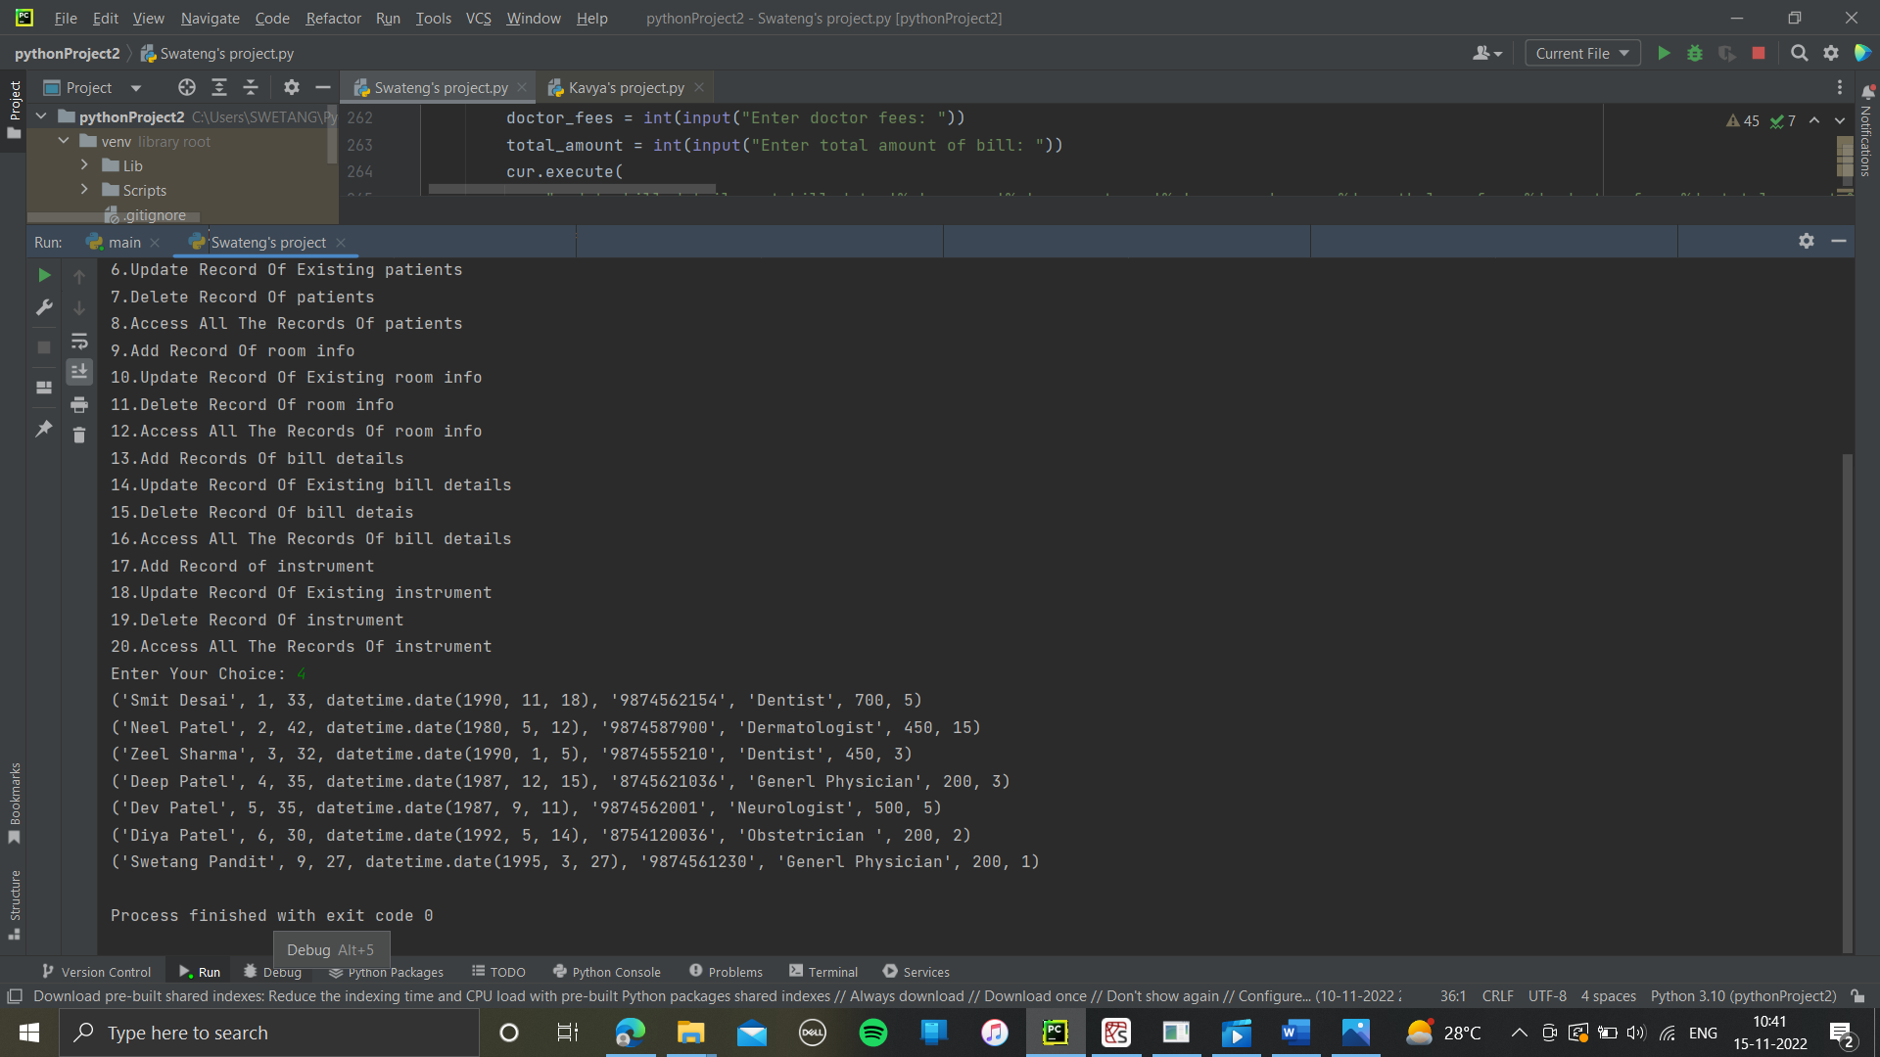

Add the record of patients:

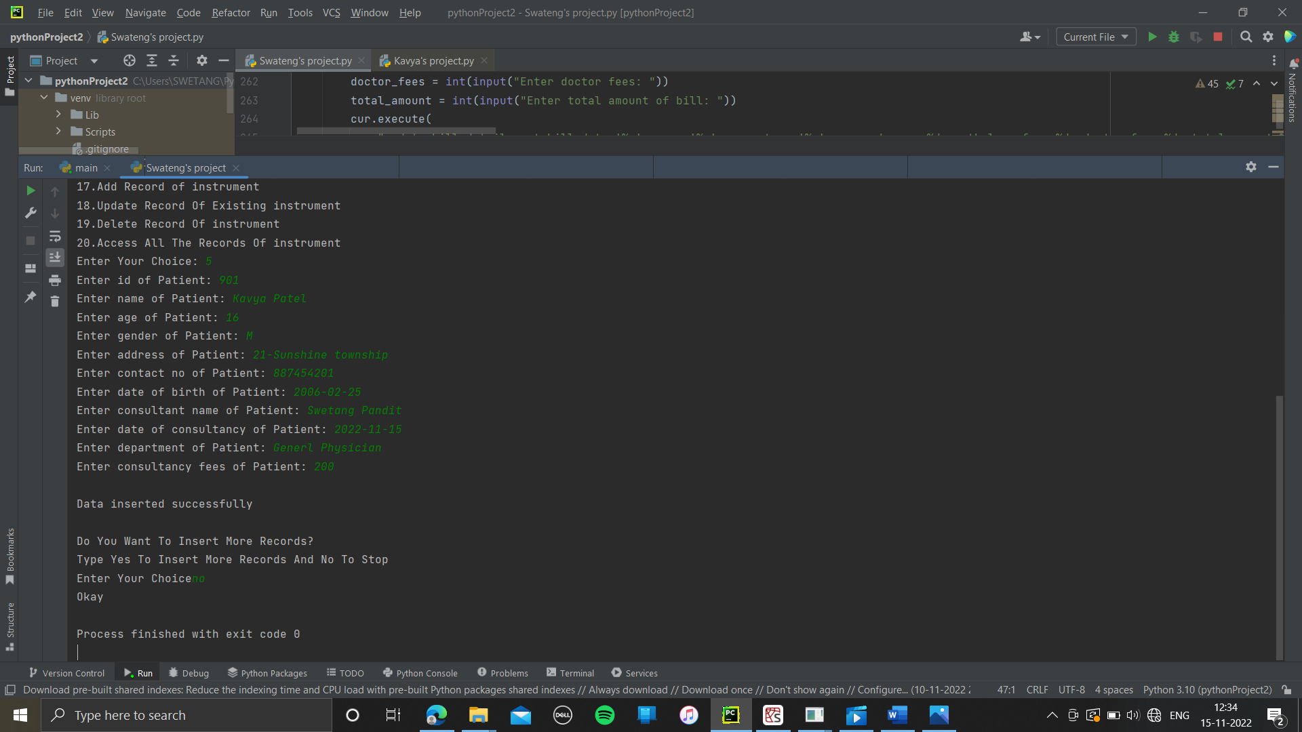

Update the record patients:

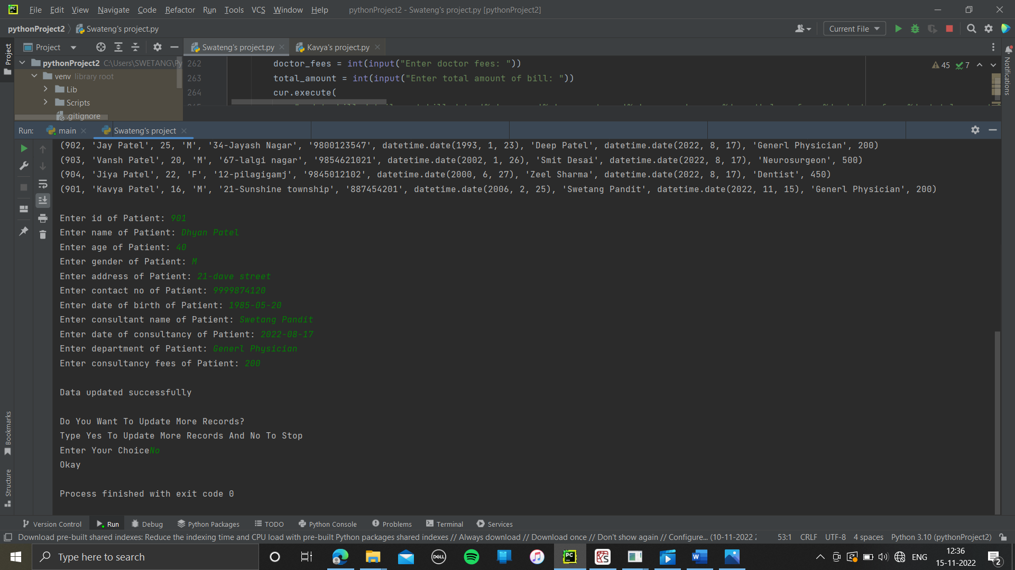

Delete the record of patients:

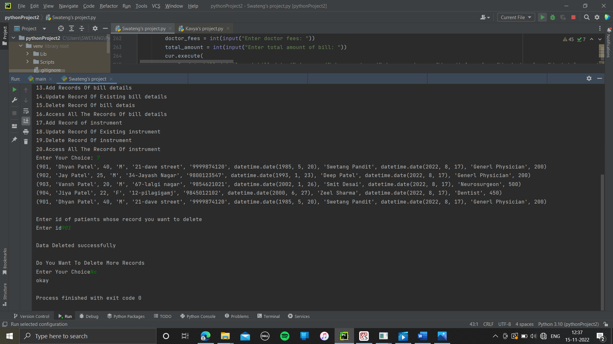

Display the record of patients:

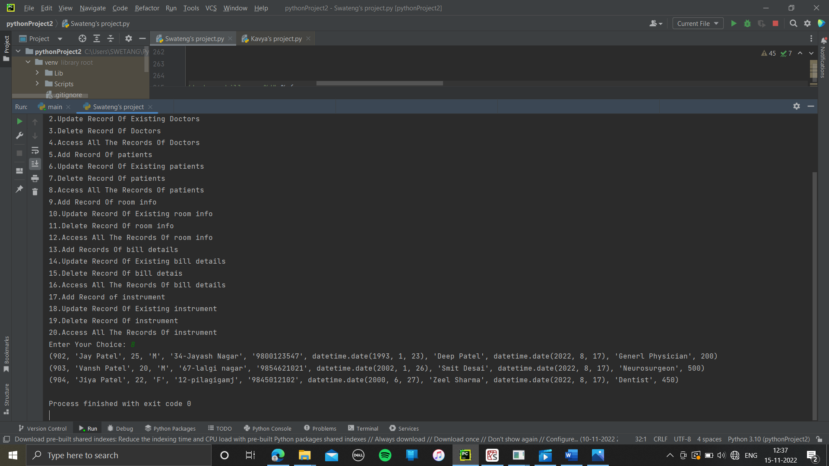

Add the record of room:

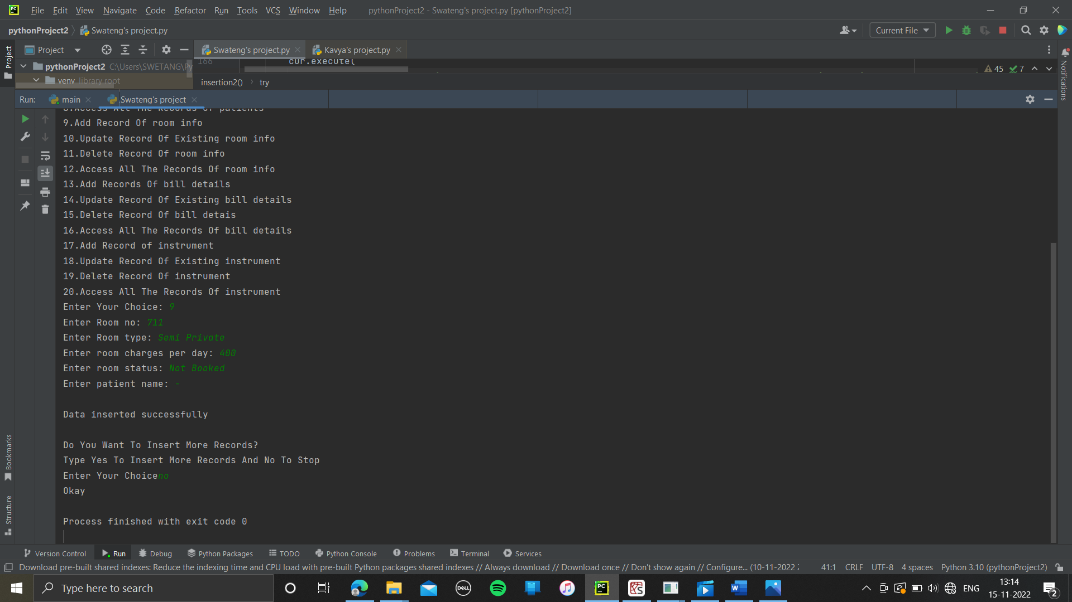

Update the record of room:

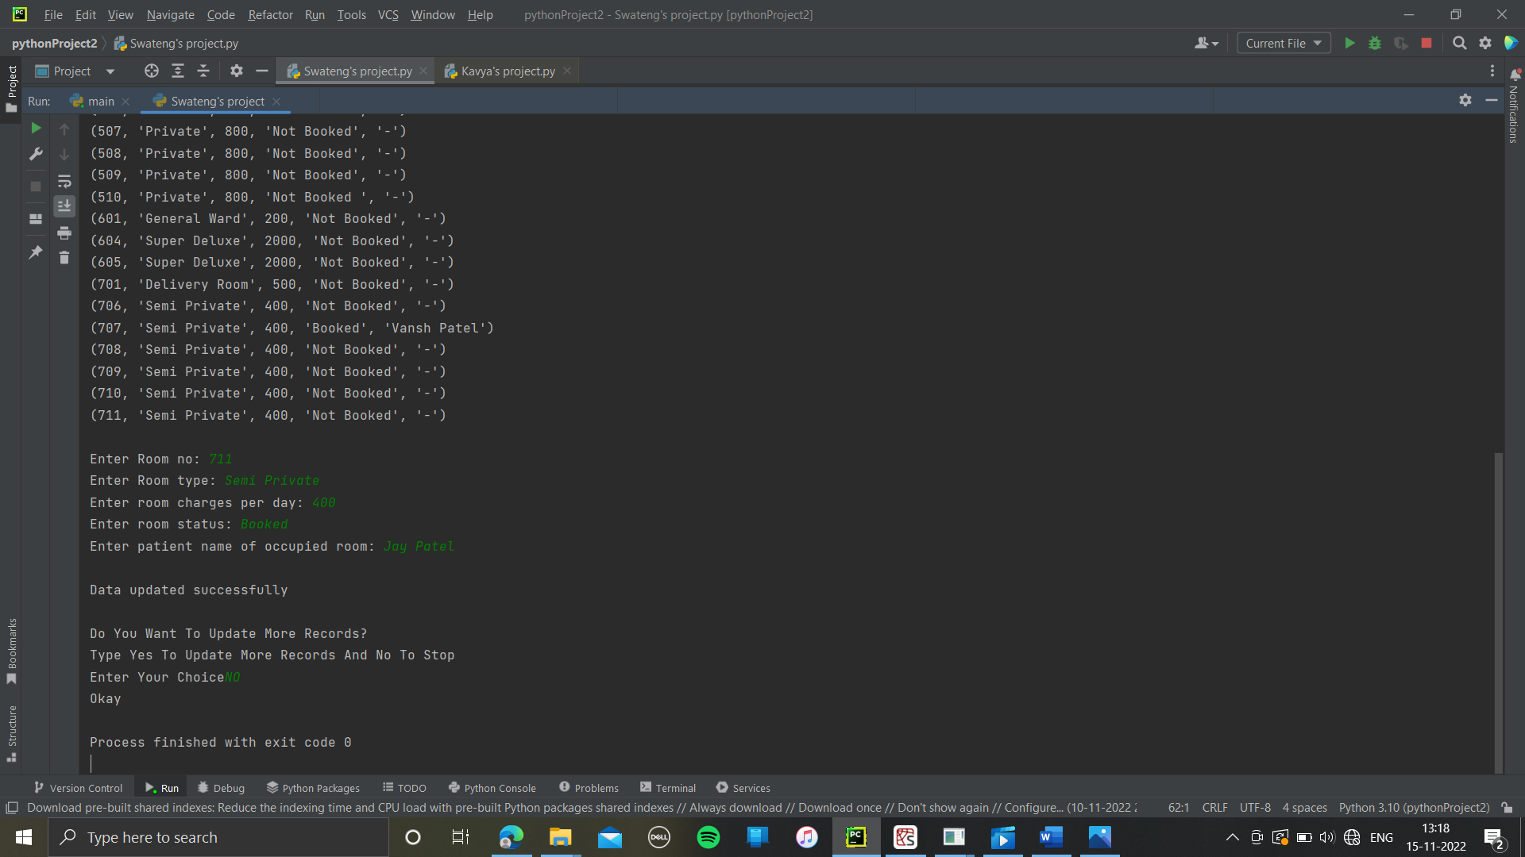

Delete the record of room:

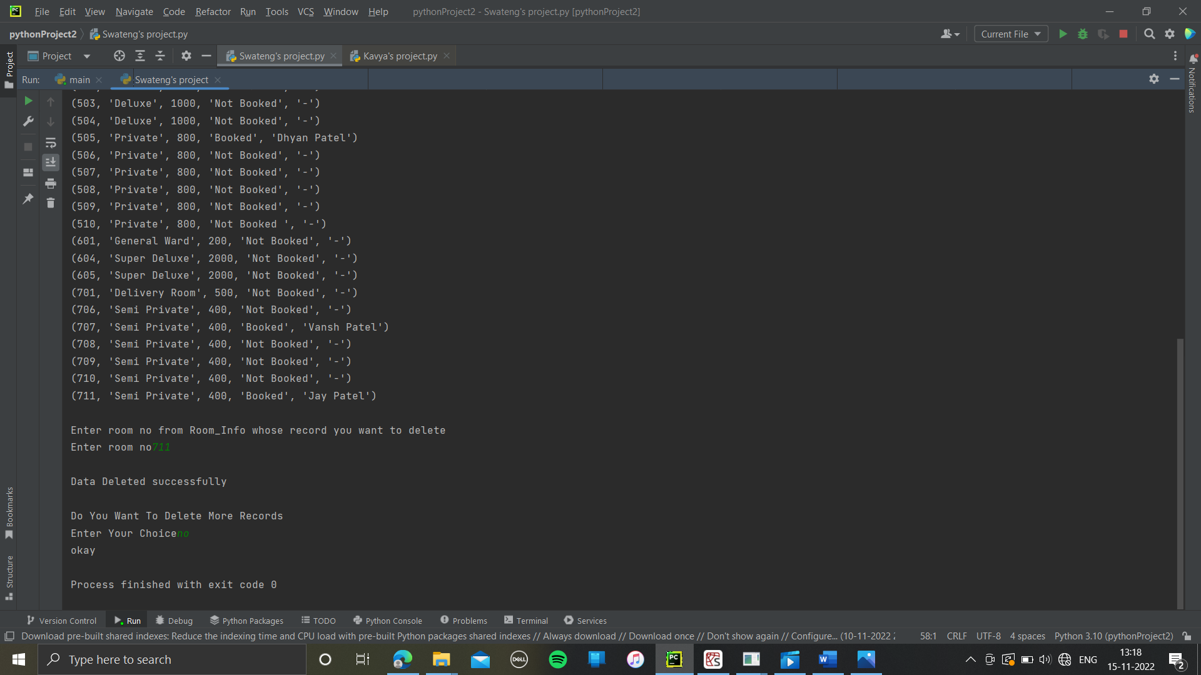

Display the record of room:

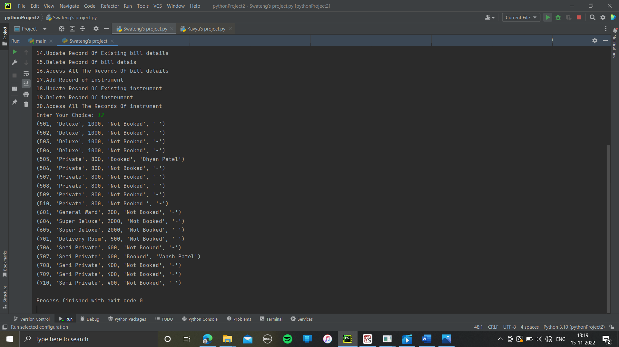

Add the record of bills:

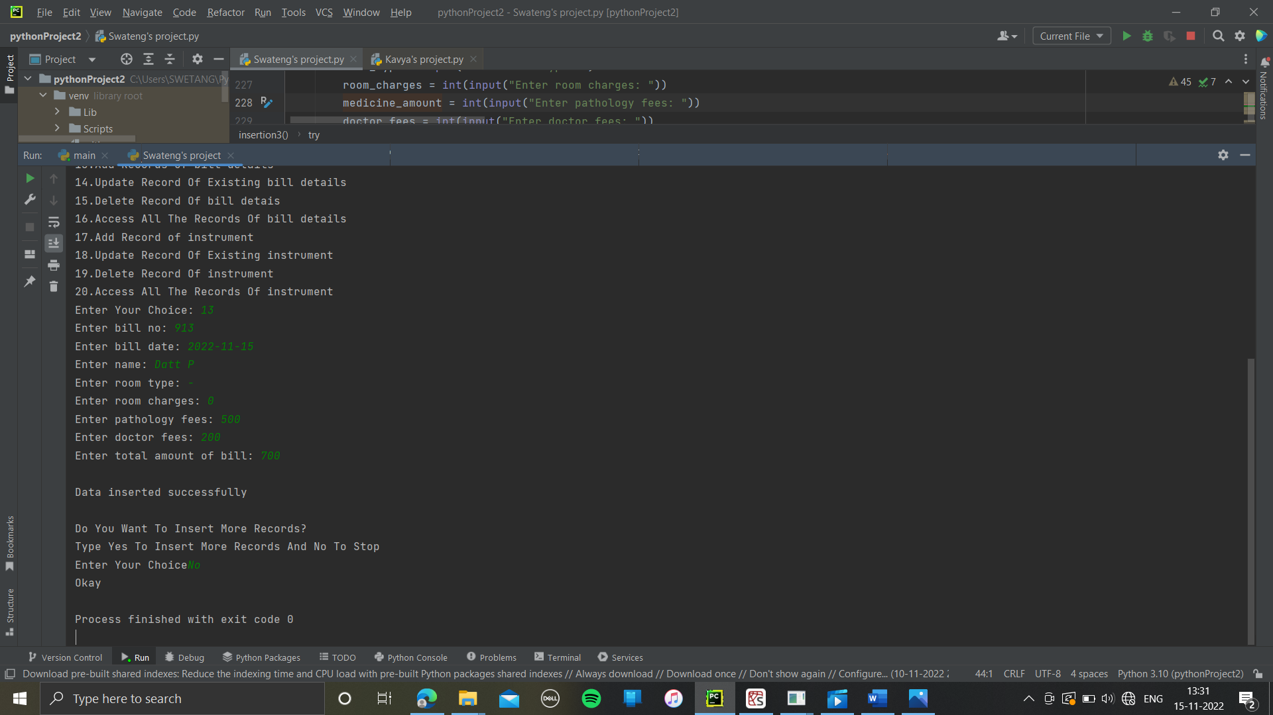

Update the record of bills:

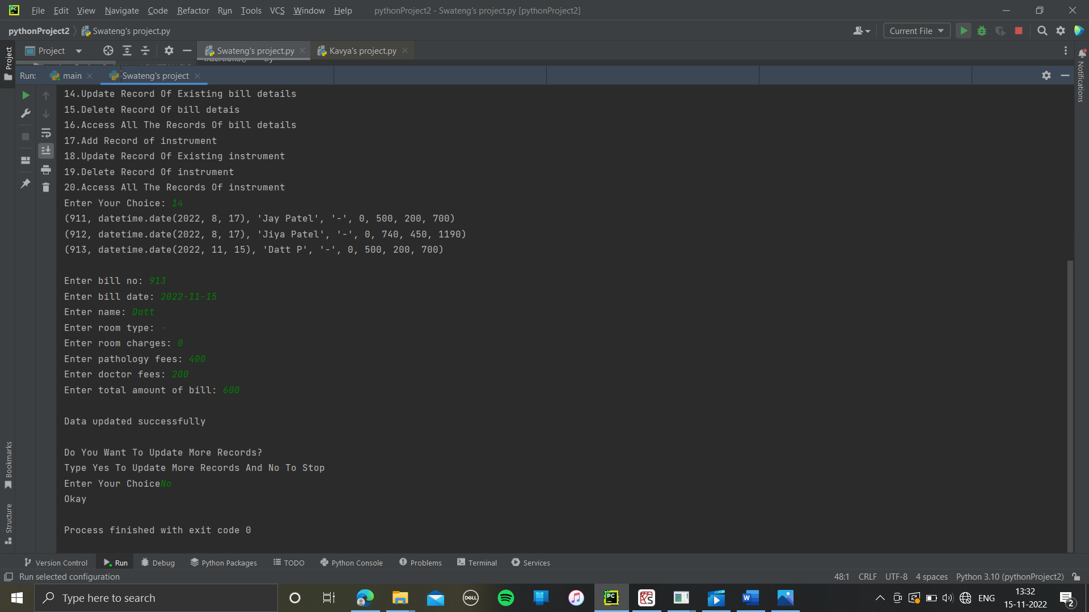

Delete the record of bills:

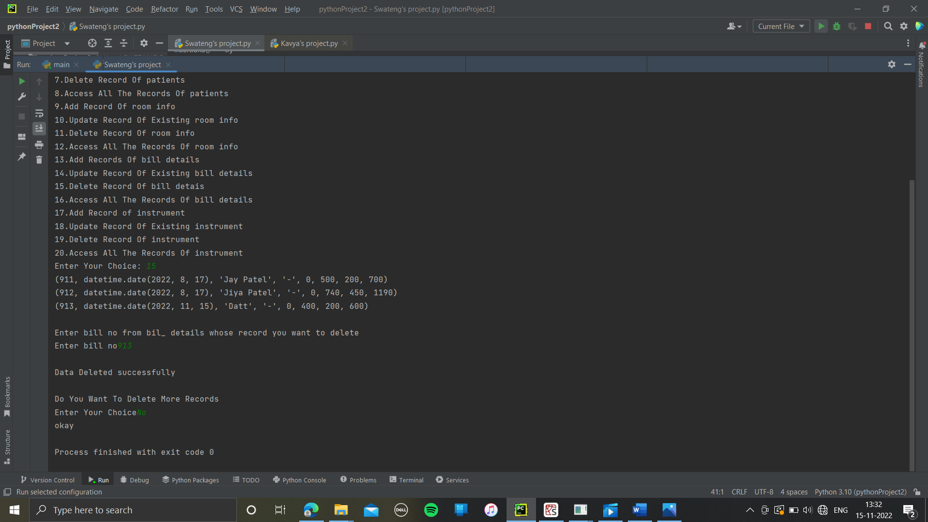

Display the record of bills:

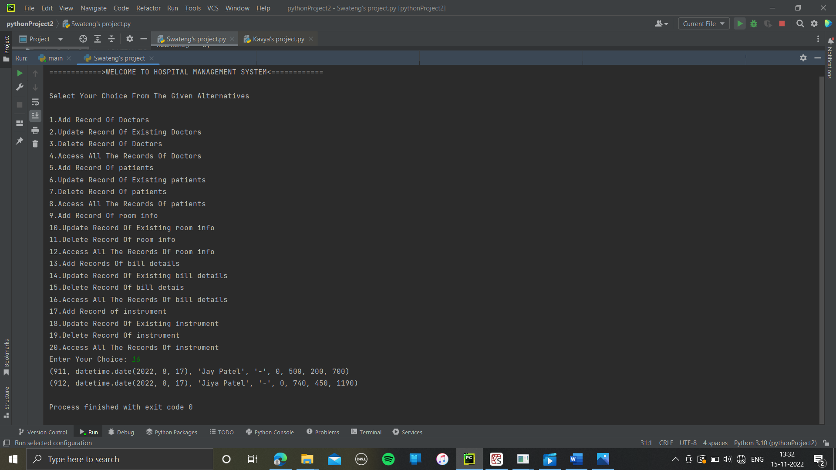

Add the record instrument:

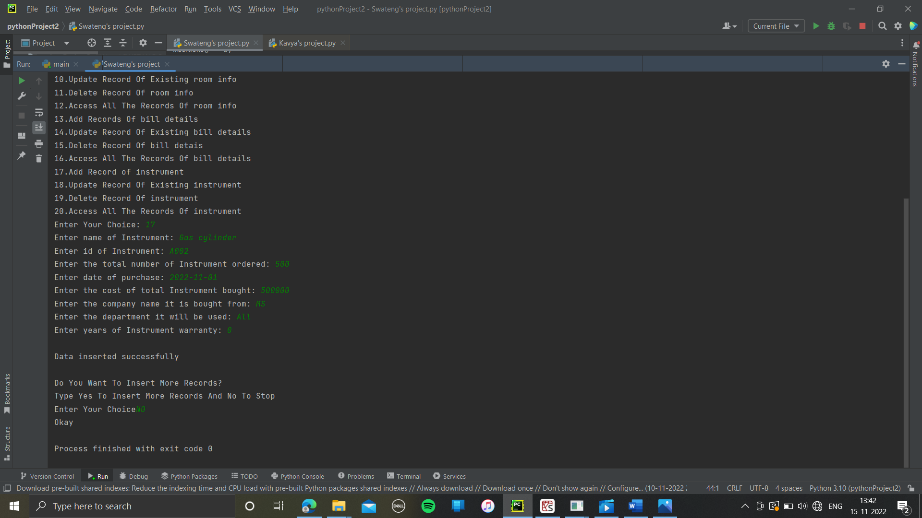

Update the record of instrument:

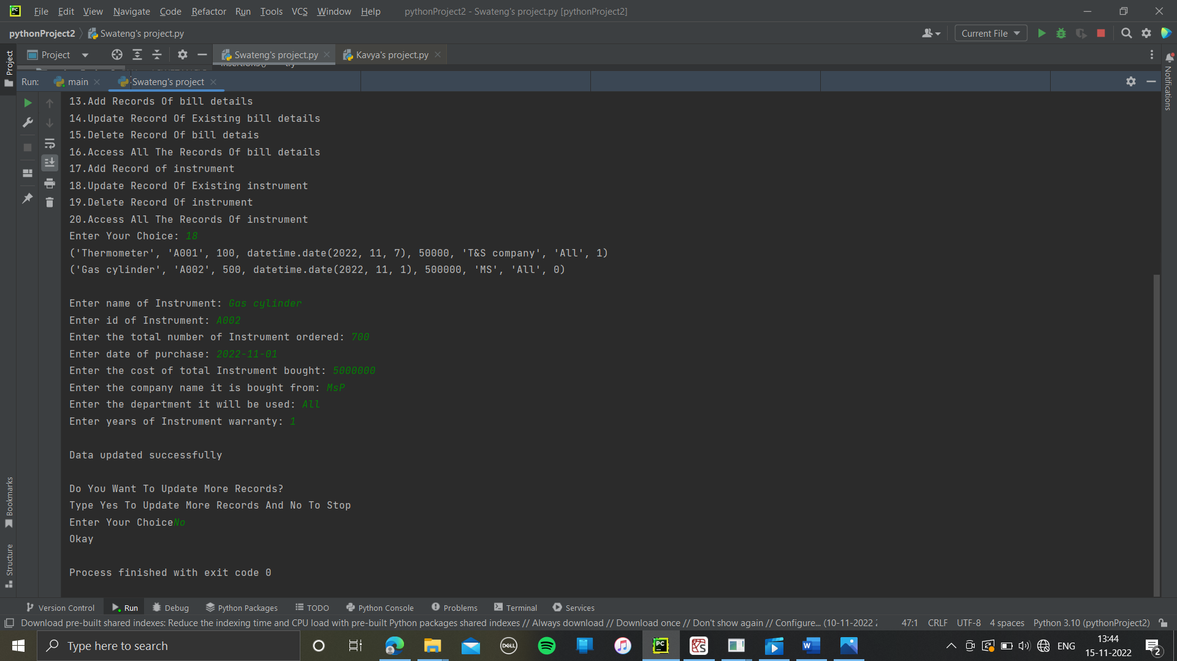

Delete the record of instrument:

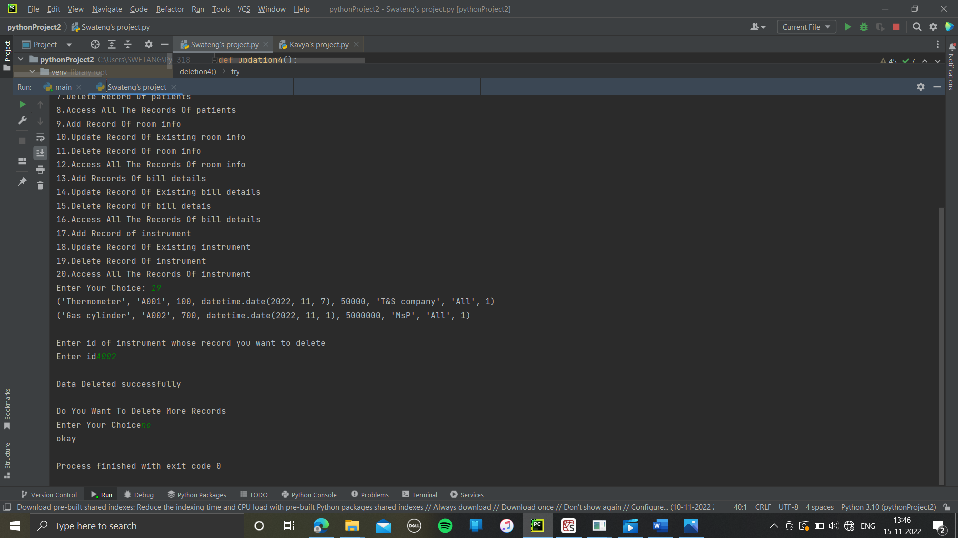

Display the record of instrument:

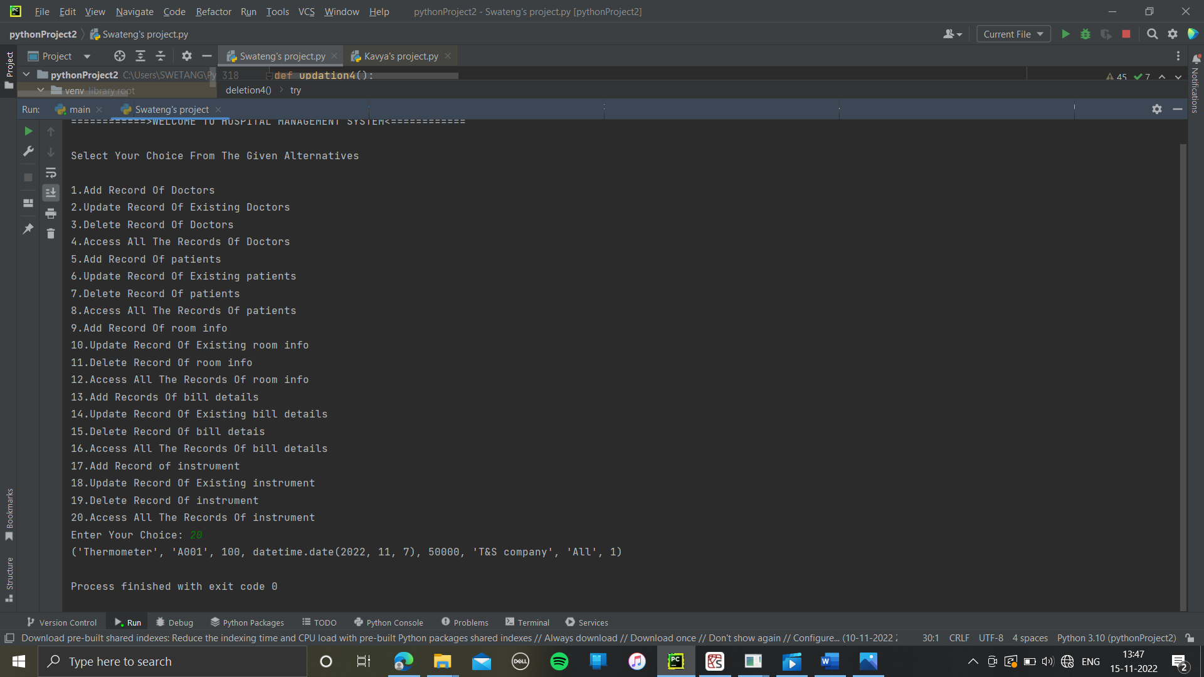

# **MY SQL OUTPUT**

DOCTORS

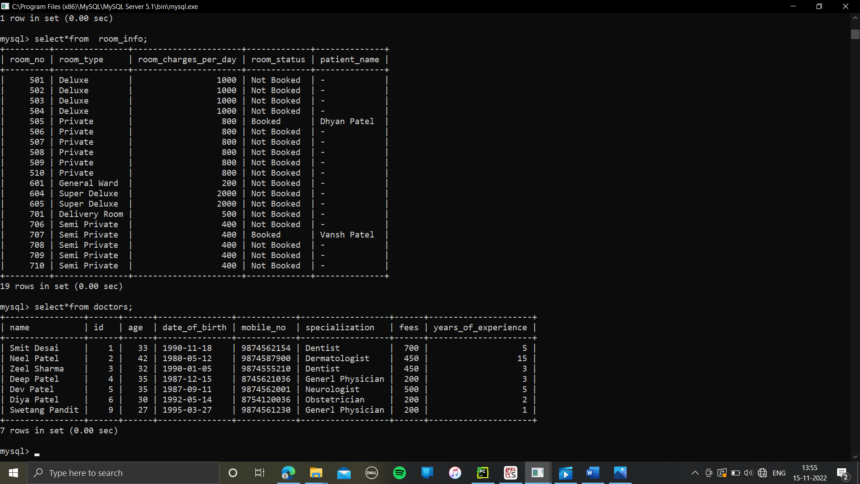

PATIENTS

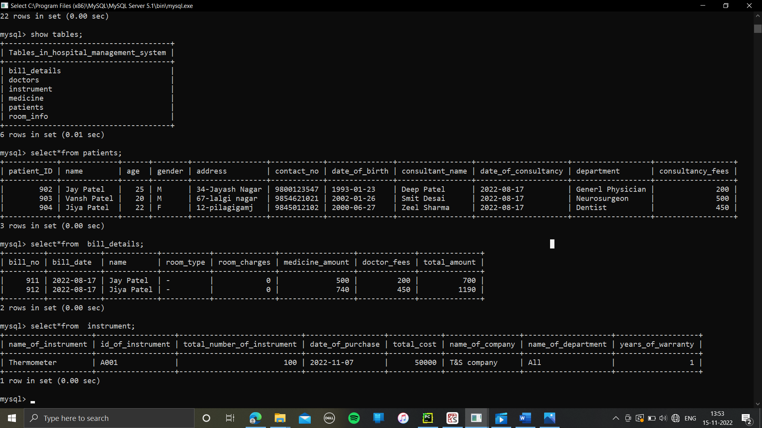

ROOM INFO

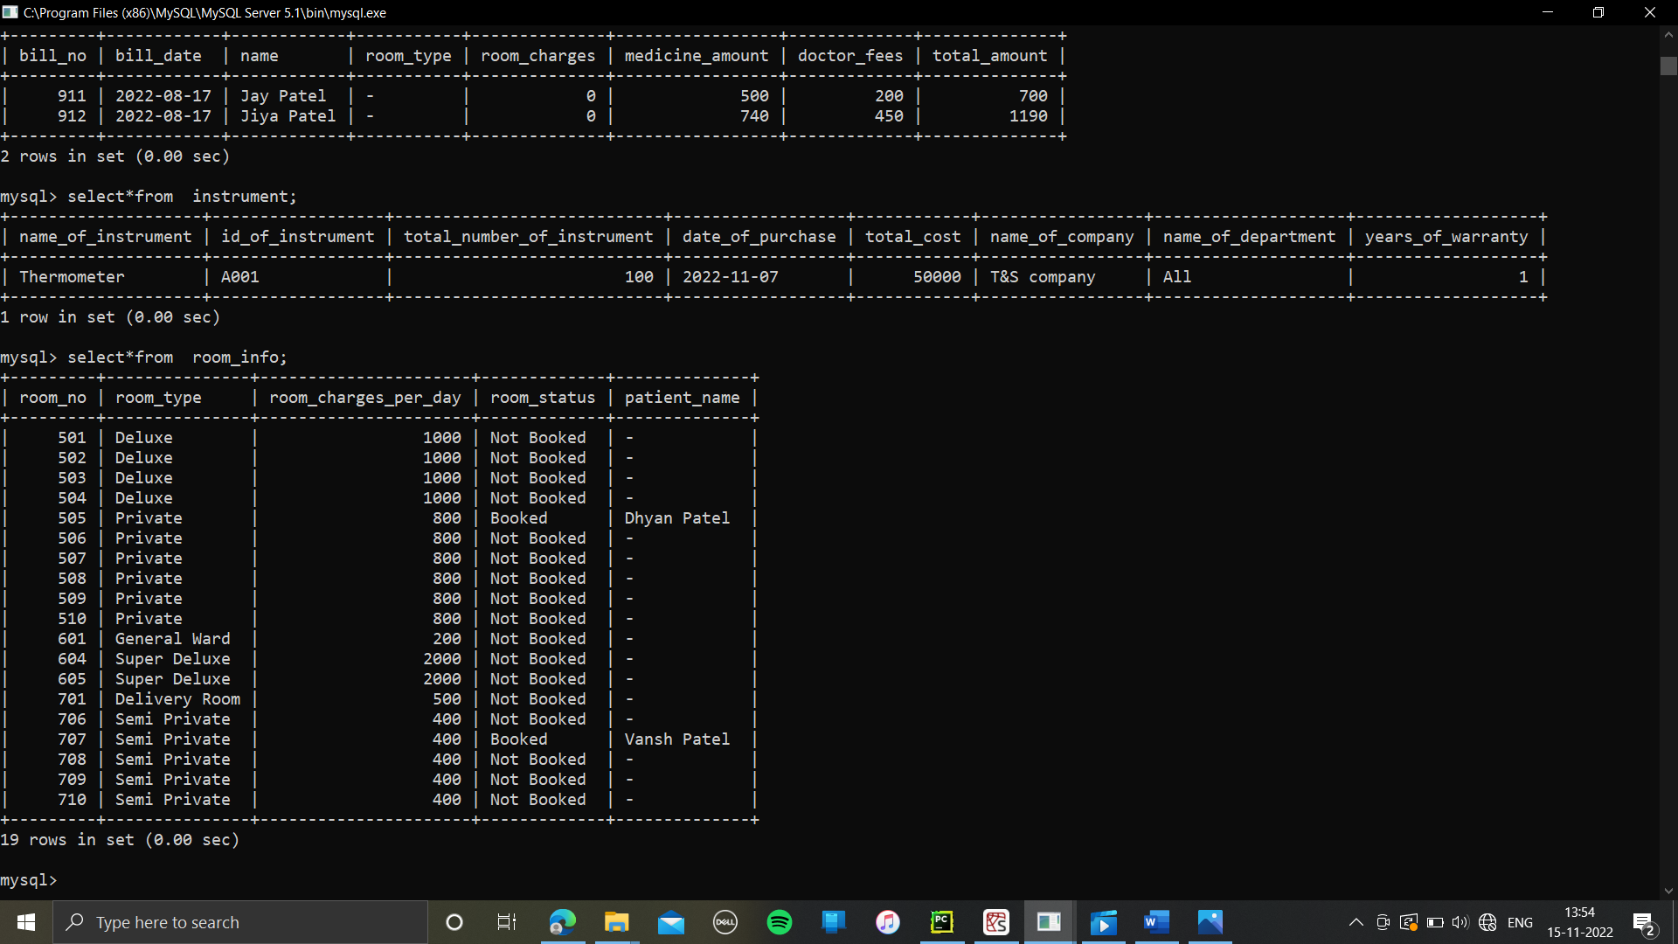

BILL DETAILS



INSTRUMENTS



# Bibliograph

[www.google.com](http://www.google.com)

Subject teacher

Computer lab

<http://www.vbdotnetheaven.com>

<http://www.connectionstrings.com>